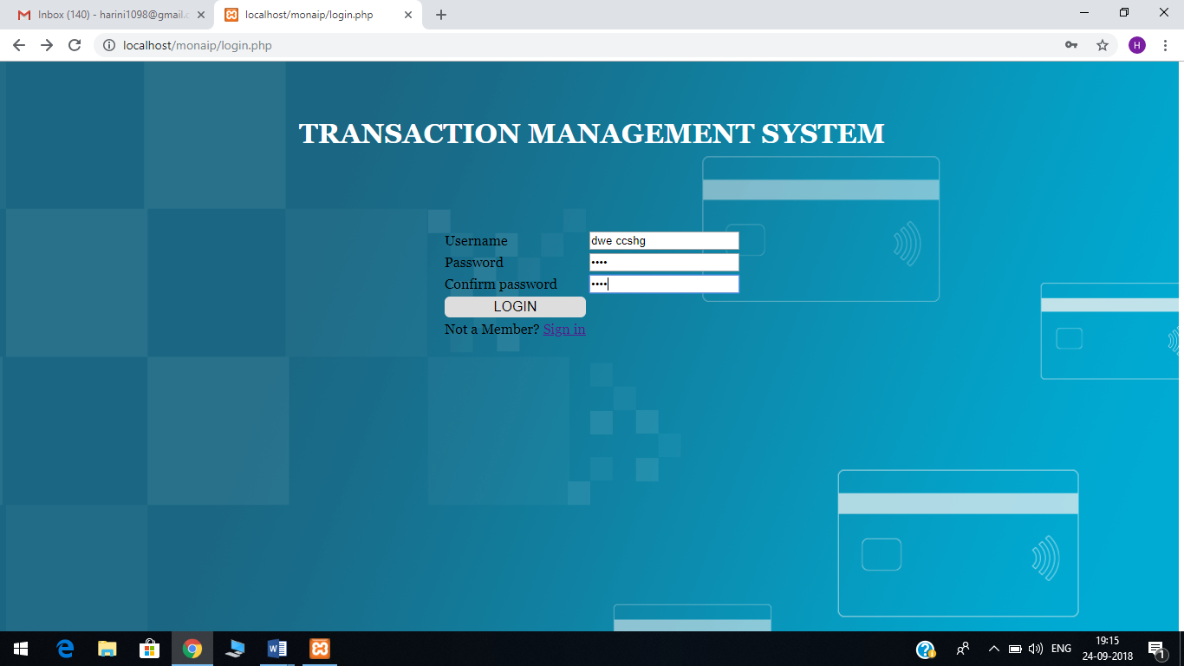

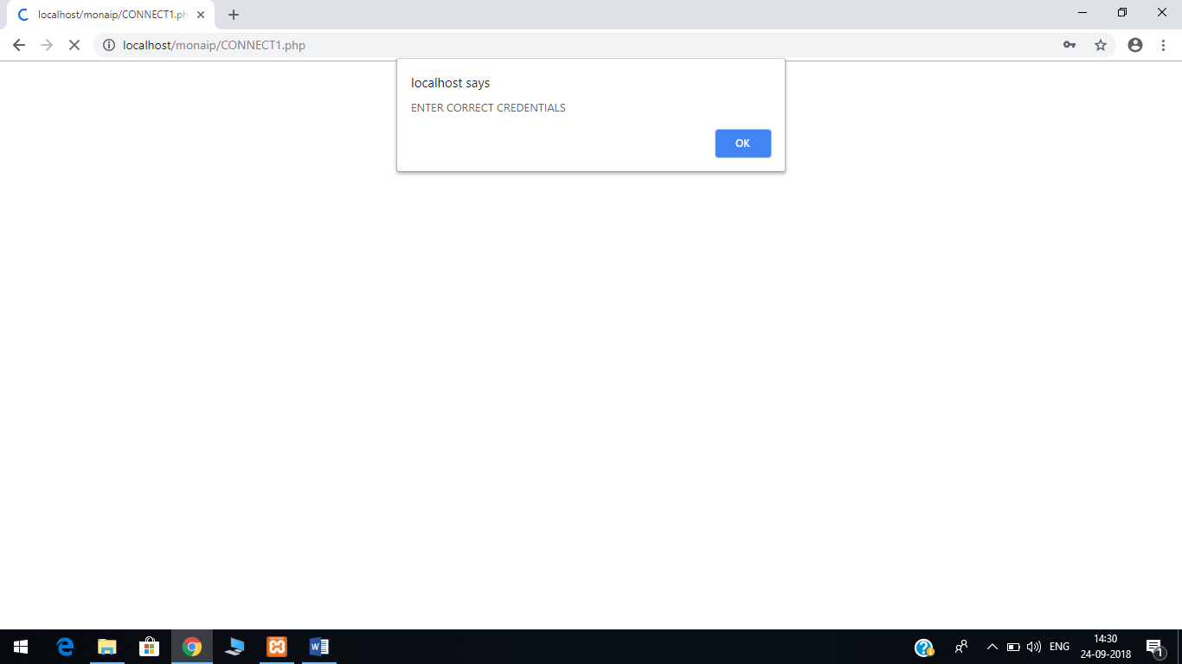

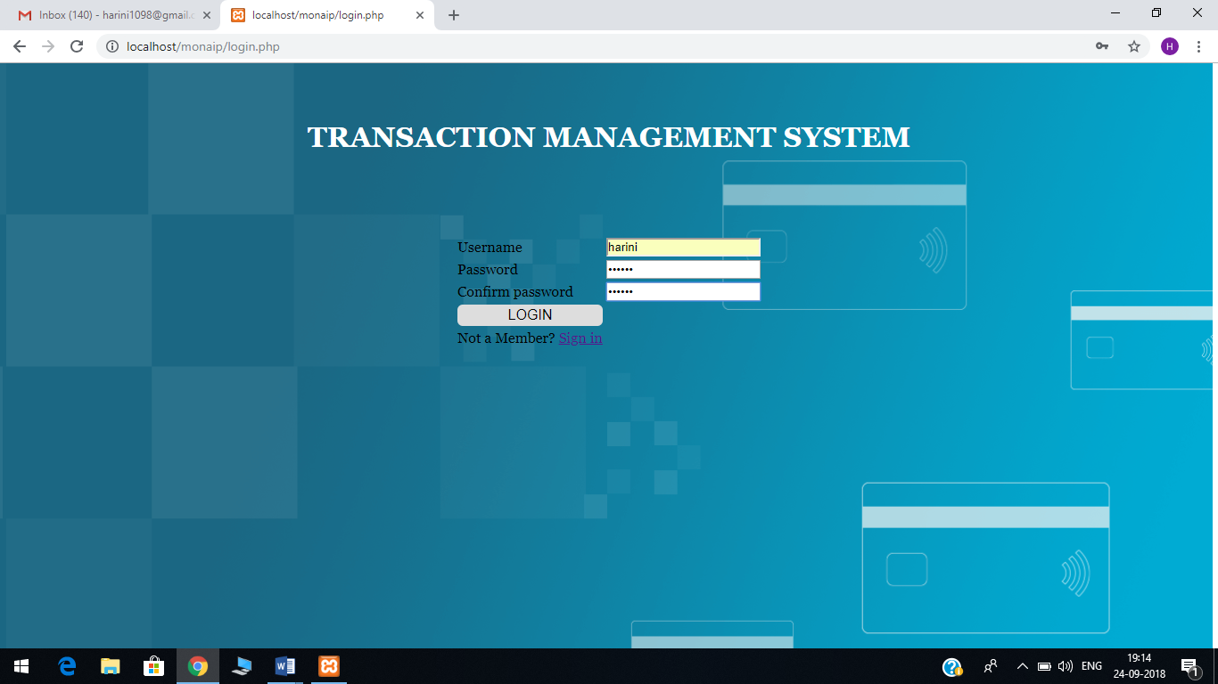

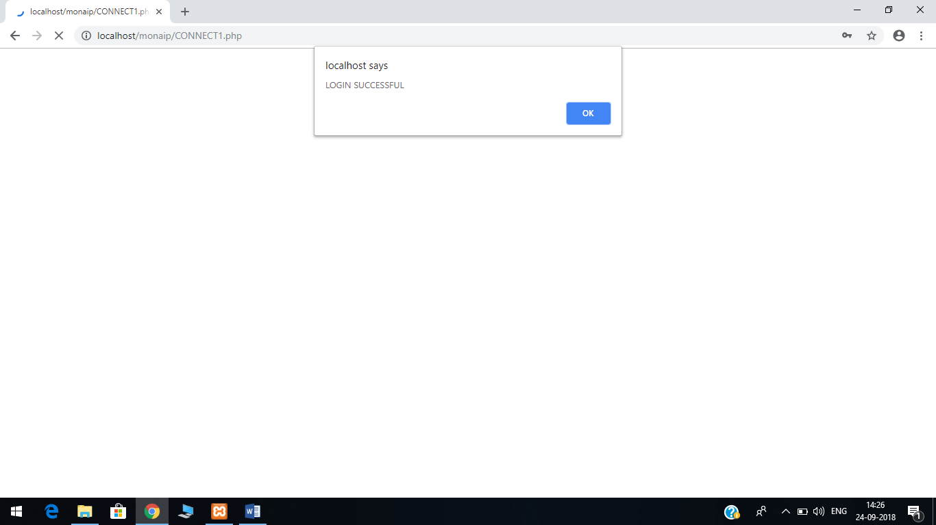



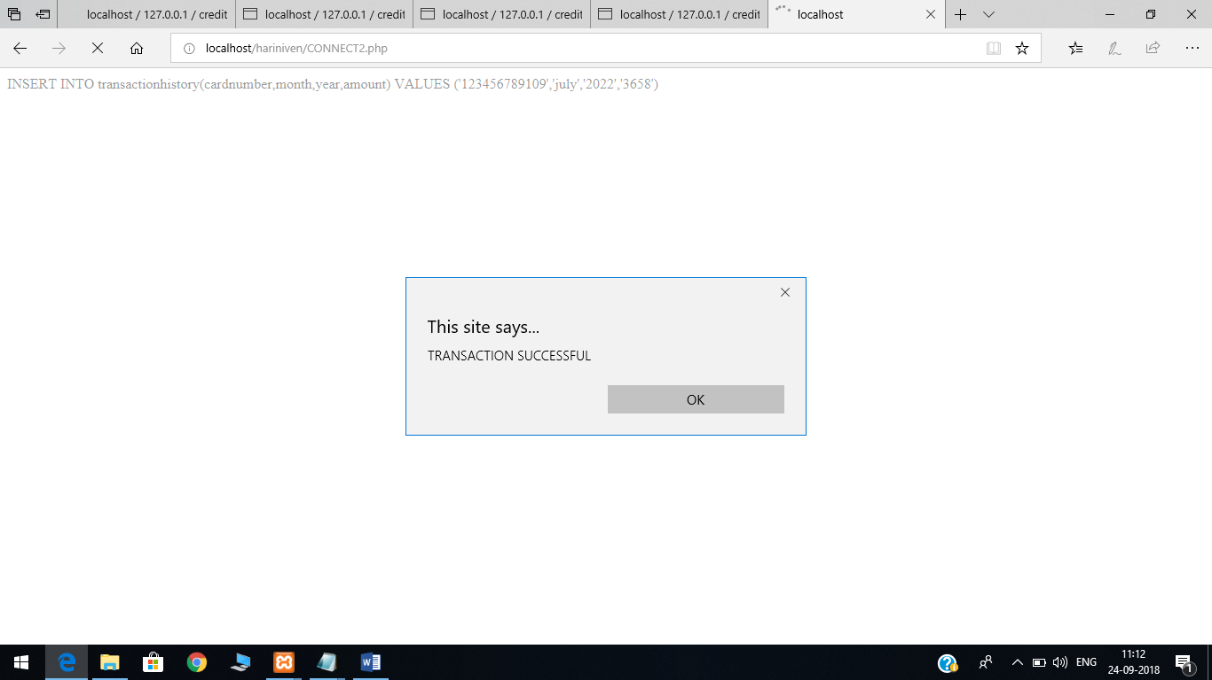

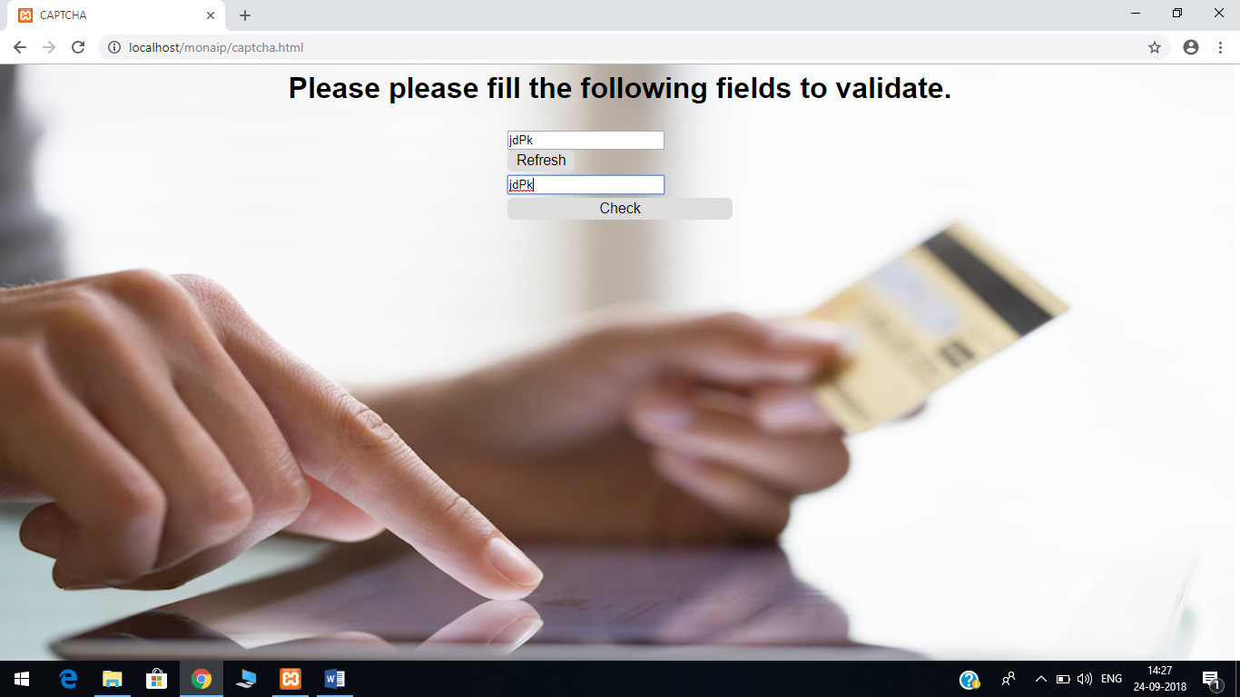

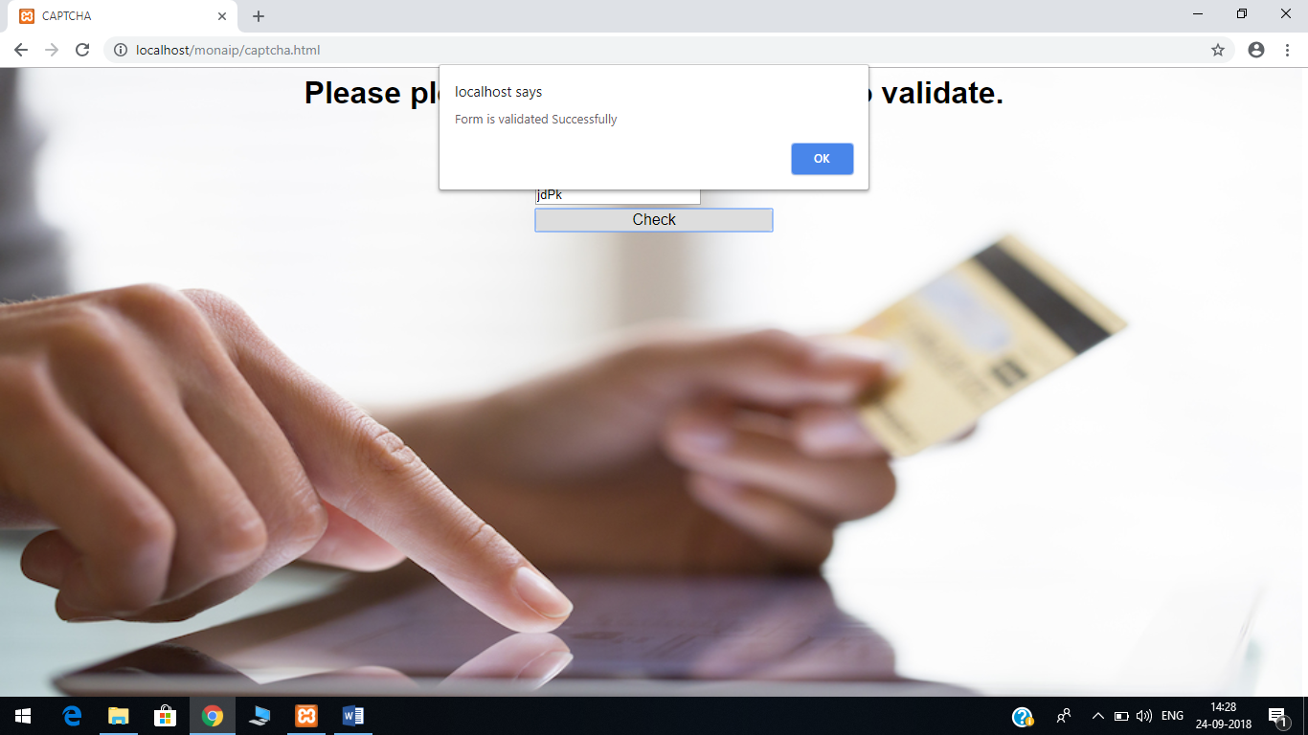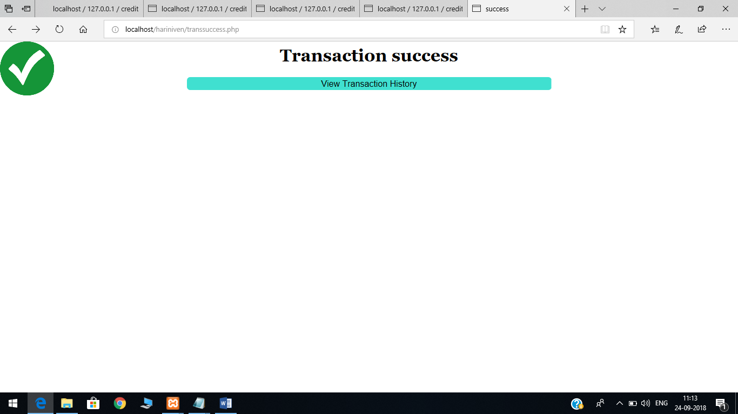

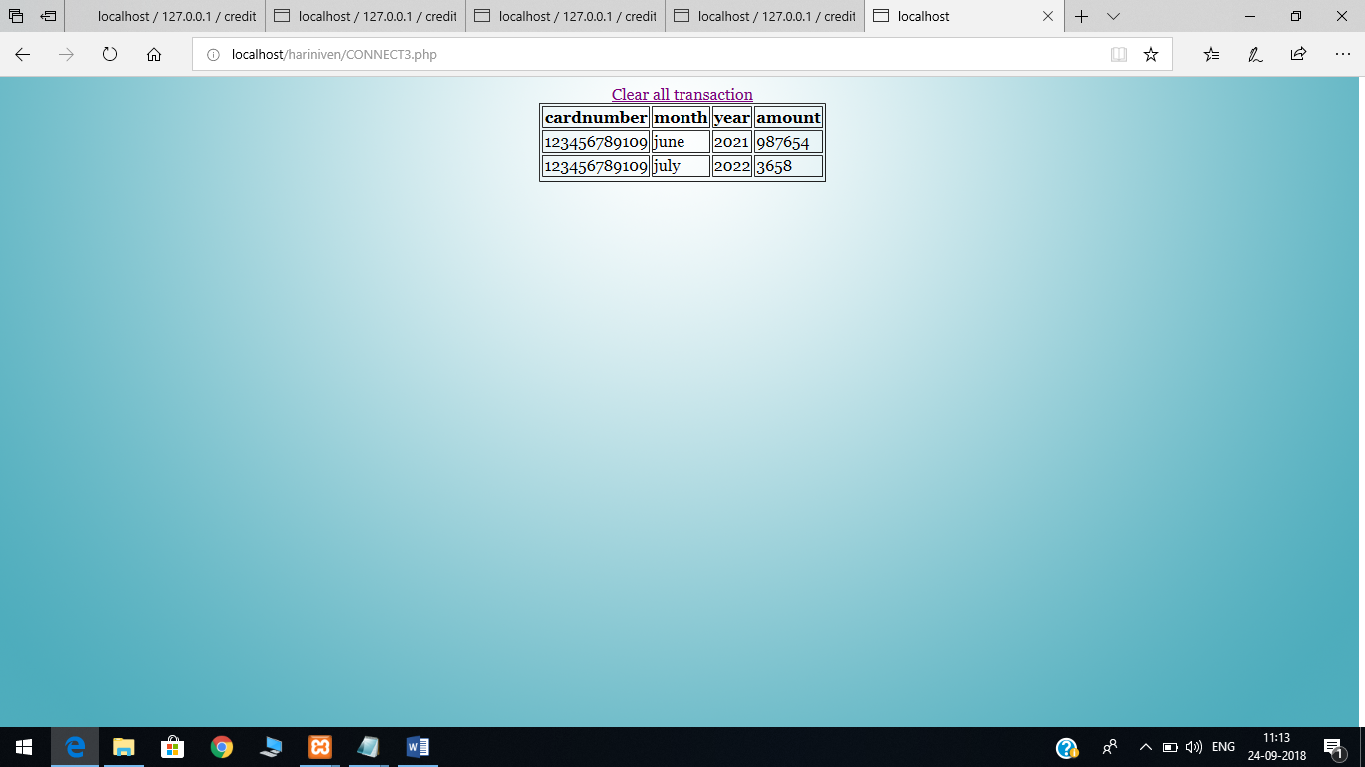

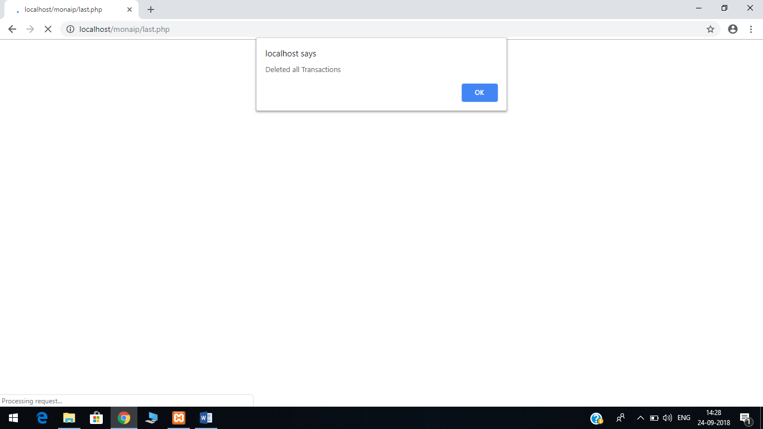

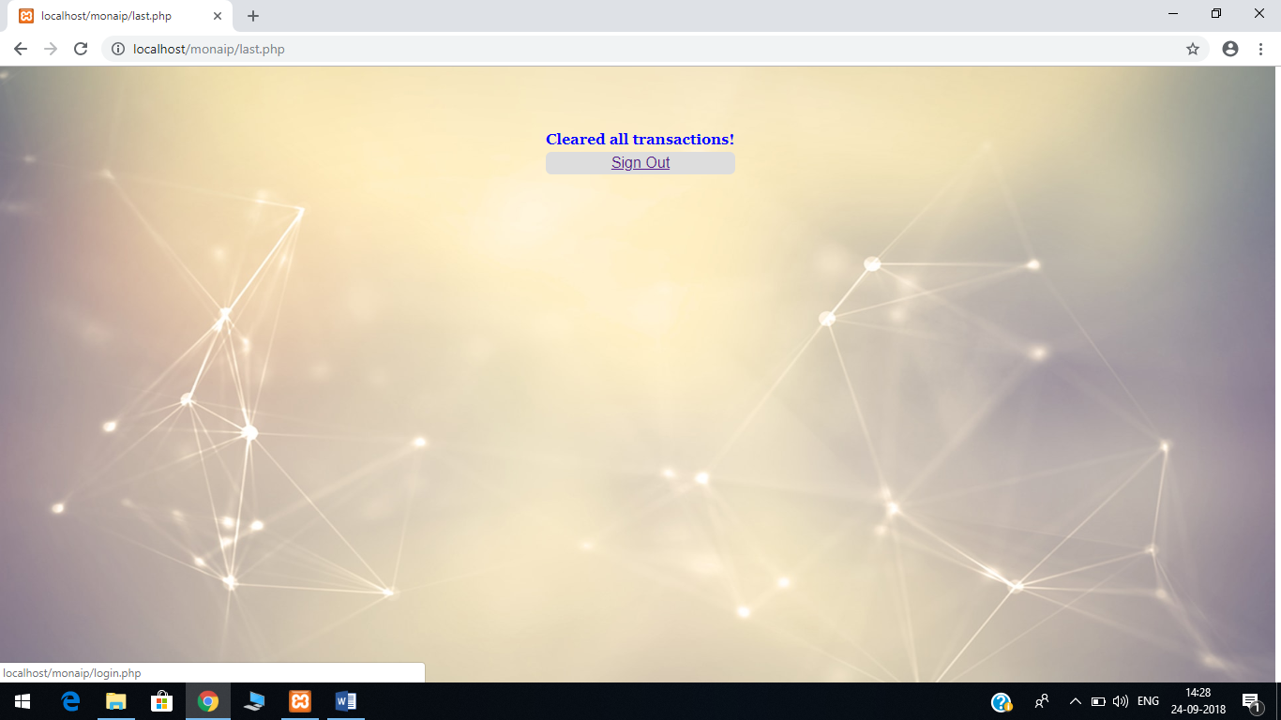

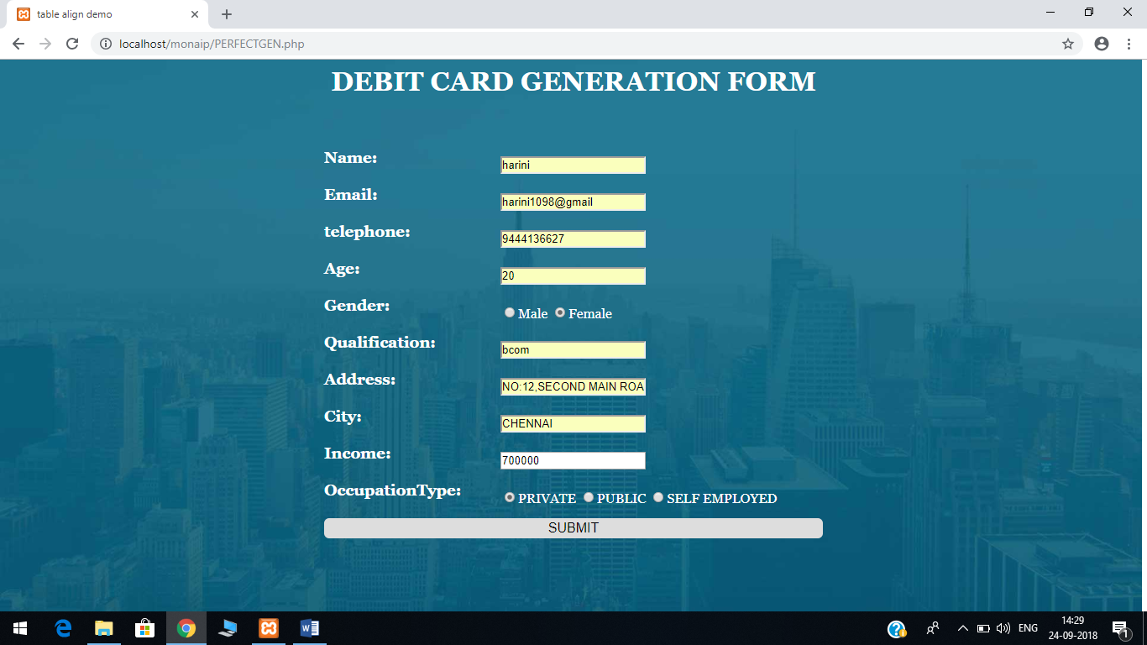

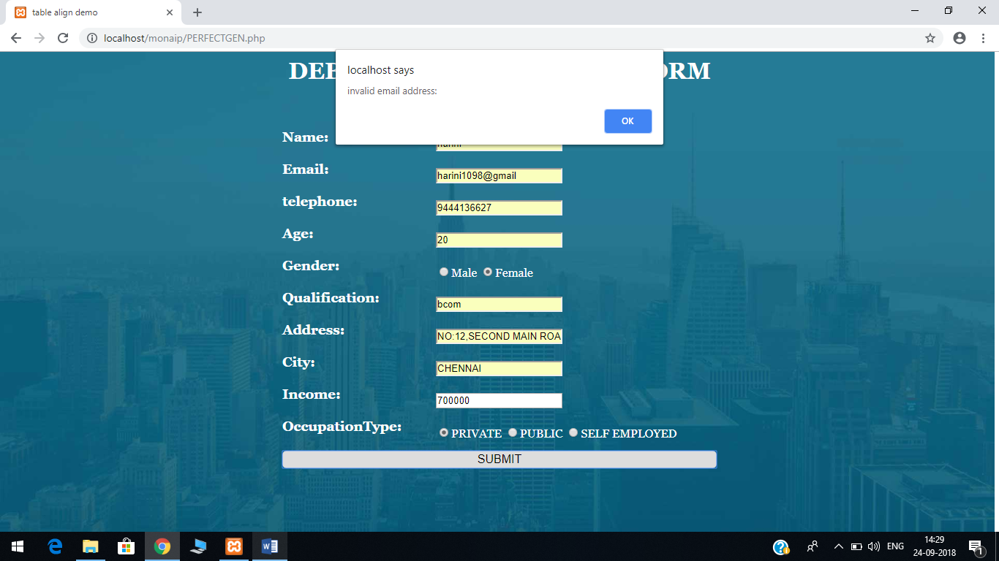

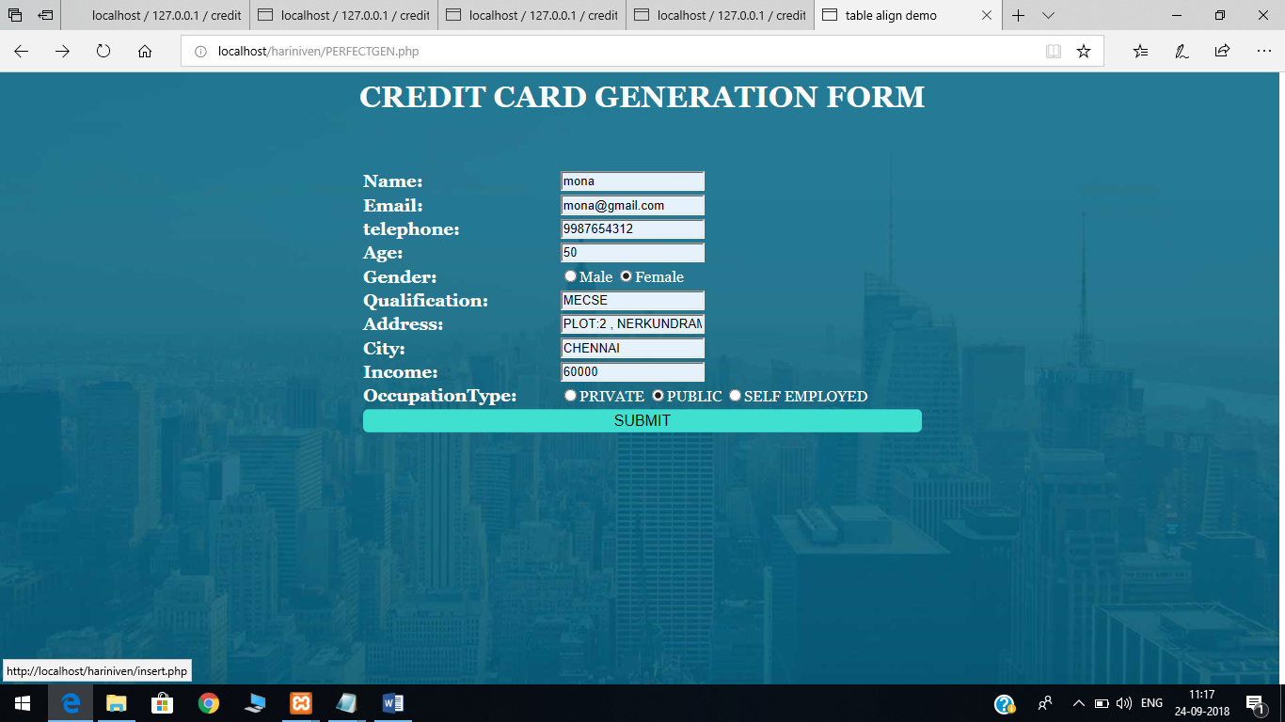



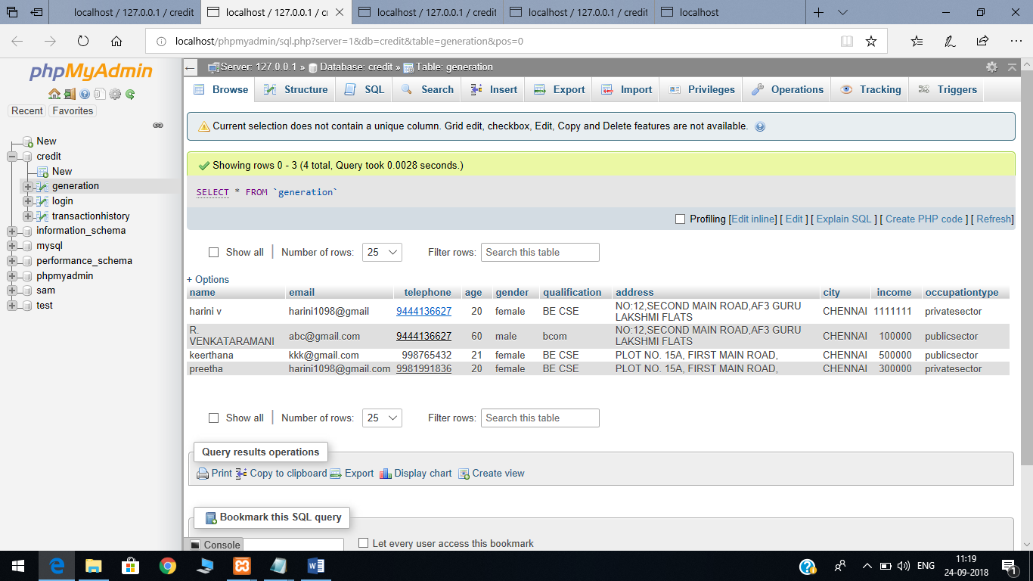

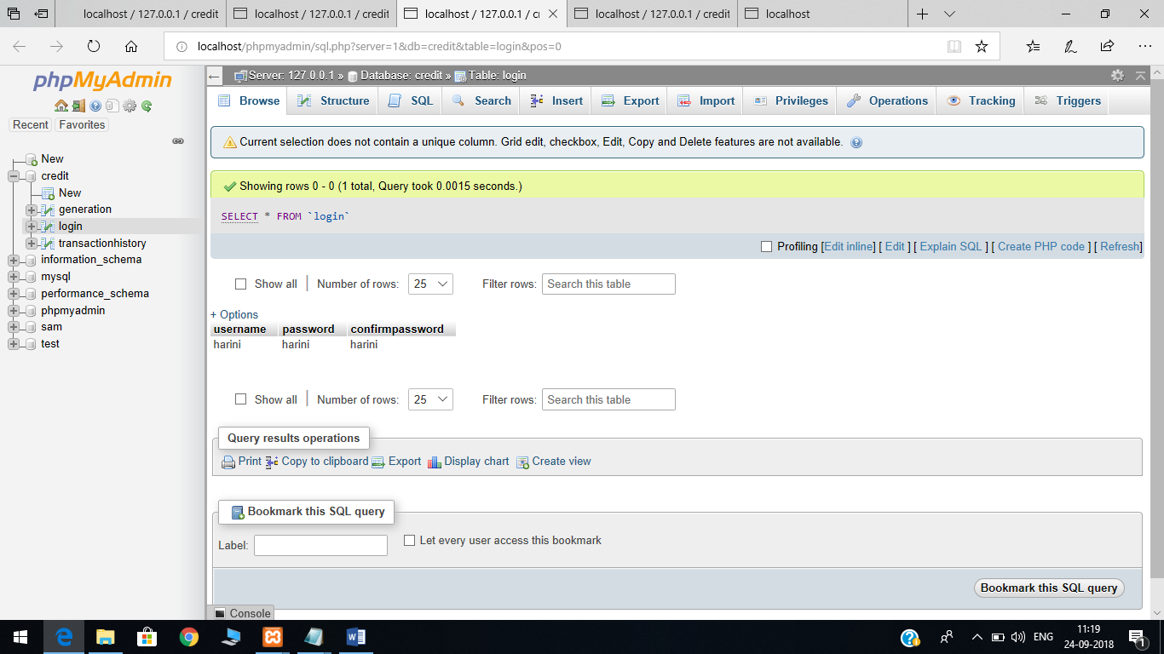

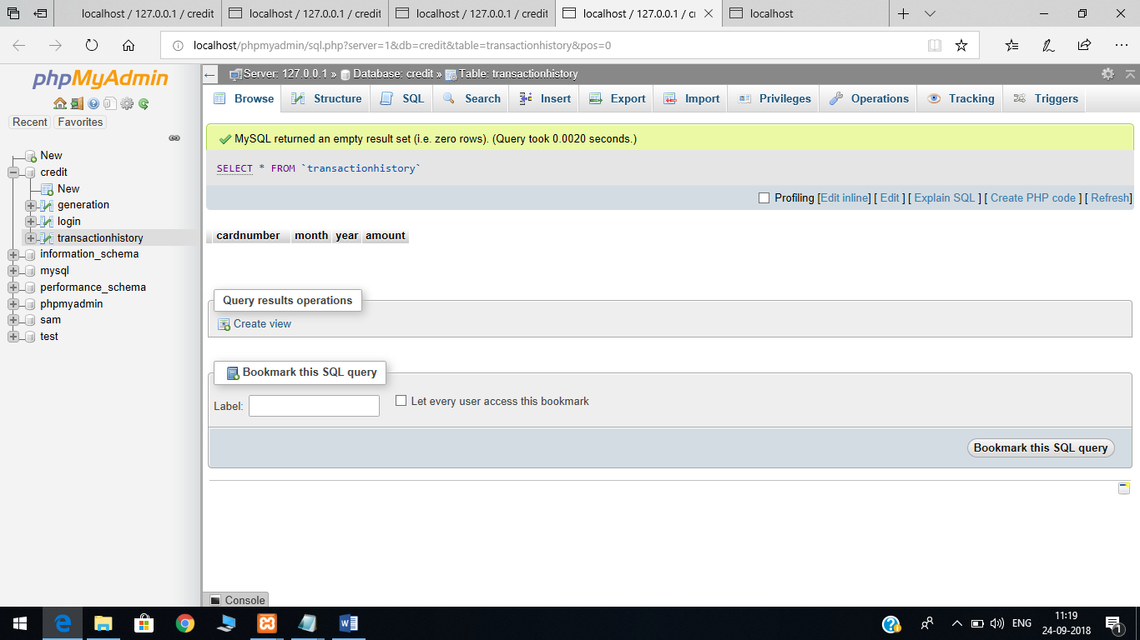

**PROGRAM:**

**Login.php**

<html>

<head>

<title></title>

</head>

<style>

body{

background-image:url(login1.png);

background-repeat: no-repeat;

background-size: 1360px 800px;

}

h1{

color:blue;

font-family: "Georgia";

}

td{

font-family: "Georgia";

}

button{

background: 40E0D0;

}

.proceed-btn {

cursor: pointer;

font-size: 16px;

width: 100%;

border-color: transparent;

border-radius: 6px;

}

</style>

<body>

<div class="header">

</br></br><h1><center>Transaction Processing System</center></h1>

</div>

<form method="post" action="CONNECT1.php">

</br></br><center><table>

<tr>

<td><div class="input-group">

<label>Username</label></td>

<td><input type="text" name="username"></td>

</div></tr>

<tr> <div class="input-group">

<td> <label>Password</label></td>

<td> <input type="password" name="password"> </td>

</div></tr>

<tr><div class="input-group">

<td><label>Confirm password</label></td>

<td><input type="password" name="confirmpassword"></td>

</div></tr>

<tr><div class="input-group">

<td><button type="submit" class="proceed-btn" name="reg_user">LOGIN</button></td>

</div></tr>

<tr></br><p>

<td> Not a Member? <a href="PERFECTGEN.php">Sign in</a> </td>

</p></tr>

</table></center>

</form>

</body>

</html>

**Perfectgen.php**

<html>

<head>

<title>table align demo</title>

<script type="text/javascript">

function validateform()

{

var namebox=document.getElementById("name");

if(namebox.value.length==0)

{

alert("enter name");

return false;

}

var re=/^\w+(?:\s\w+){0,3}$/;

if(!namebox.value.match(re))

{

alert("invalid name");

return false;

}

var re=/^\w+([\.-]?\w+)*@\w+([\.-]?\w+)*(\.\w{2,3})+$/;

var emailbox=document.getElementById("email");

if(emailbox.value.length==0)

{

alert("enter email");

return false;

}

if(!emailbox.value.match(re))

{

alert("invalid email address:");

return false;

}

var re=/^\d{7,16}$/;

var telbox=document.getElementById("telephone");

if(telbox.value.length==0)

{

alert("enter phone number");

return false;

}

if(telbox.value.length>0)

{

if(!telbox.value.match(re))

{

alert("invalid telephone number");

return false;

}

}

var malebox=document.getElementById("male");

var femalebox=document.getElementById("female");

if(!malebox.checked&&!femalebox.checked)

{

alert("specify gender");

return false;

}

return true;

}

</script>

<style>

body{

font-family: "Georgia";

color: white;

background-image:url(signup.jpg);

background-repeat: no-repeat;

background-size: 1360px 800px;

}

.proceed-btn {

cursor: pointer;

font-size: 16px;

width: 100%;

border-color: transparent;

border-radius: 6px;

background: 40E0D0;

}

</style>

</head>

<body><center>

<h1>DEBIT CARD GENERATION FORM</h1><br><br>

<form action="insert.php" method="POST">

<table style="width:600px;">

<tr>

<td style="width:35%;">

<h3>Name:</h3>

</td>

<td style="width:65%;">

<input id="name" type="text" name="name" maxlength="52"/>

</td>

</tr>

<tr>

<td style="width:35%;">

<h3>Email:</h3>

</td>

<td style="width:65%;">

<input id="email" type="text" name="email" maxlength="16"/>

</td>

</tr>

<tr>

<td style="width:35%;">

<h3>telephone:</h3>

</td>

<td style="width:65%;">

<input id="telephone" type="text" name="telephone" maxlength="10"/>

</td>

</tr>

<tr>

<td style="width:35%;">

<h3>Age:</h3>

</td>

<td style="width:65%;">

<input id="age" type="text" name="age" maxlength="2"/>

</td>

</tr>

<tr>

<td style="width:35%;">

<h3>Gender:</h3>

</td>

<td style="width:65%;">

<input id="male" type="radio" value="male" name="gender"/>Male

<input id="female" type="radio" value="female" name="gender"/>Female

</td>

</tr>

<tr>

<td style="width:35%;">

<h3>Qualification:</h3>

</td>

<td style="width:65%;">

<input id="qualification" type="text" name="qualification" maxlength="22"/>

</td>

</tr>

<tr>

<td style="width:35%;">

<h3>Address:</h3>

</td>

<td style="width:65%;">

<input id="address" type="text" name="address" maxlength="72"/>

</td>

</tr>

<tr>

<td style="width:35%;">

<h3>City:</h3>

</td>

<td style="width:65%;">

<input id="city" type="text" name="city" maxlength="12"/>

</td>

</tr>

<tr>

<td style="width:35%;">

<h3>Income:</h3>

</td>

<td style="width:65%;">

<input id="income" type="text" name="income" maxlength="12"/>

</td>

</tr>

<tr>

<td style="width:35%;">

<h3>OccupationType:</h3>

</td>

<td style="width:95%;">

<input id="privatesector" type="radio" value="privatesector" name="occupationtype"/>PRIVATE

<input id="publicsector" type="radio" value="publicsector" name="occupationtype"/>PUBLIC

<input id="selfemployed" type="radio" value="selfemployed" name="occupationtype"/>SELF EMPLOYED

</td>

</tr>

<td colspan="2" style="width:100%;">

<input type="submit" value="SUBMIT" class="proceed-btn" onclick="validateform()"/>

</td></tr>

</table>

</form>

</body>

</html>

**Insert.php**

<?php

include("connect.php");

$f1=$f2=$f3=$f4=$f5=$f6=$f7=$f8=$f9=$f10=" ";

if($_SERVER['REQUEST_METHOD']=="POST")

{

$f1=$_POST["name"];

$f2=$_POST["email"];

$f3=$_POST["telephone"];

$f4=$_POST["age"];

$f5=$_POST["gender"];

$f6=$_POST["qualification"];

$f7=$_POST["address"];

$f8=$_POST["city"];

$f9=$_POST["income"];

$f10=$_POST["occupationtype"];

$query= "INSERT INTO generation (name,email,telephone,age,gender,qualification,address,city,income,occupationtype) VALUES ('$f1','$f2','$f3','$f4','$f5','$f6','$f7','$f8','$f9','$f10')";

if(mysqli_query($con,$query))

{

$f1=$f2=$f3=$f4=$f5=$f6=$f7=$f8=$f9=$f10=" ";

}

else{echo mysqli_error($con);}

}

?>

<html>

<body>

Successfully Registered!

<a href="login.php">Go To Home</a>

</body>

</html>

**Connect.php**

<?php

$con=new mysqli('localhost','root','','credit');

if(!$con)

{

echo "unable to connect";

}

?>

**LOGIN.php**

<html>

<head>

<title></title>

</head>

<style>

body{

background-image:url(login1.png);

background-repeat: no-repeat;

background-size: 1360px 800px;

}

h1{

color:blue;

font-family: "Georgia";

}

td{

font-family: "Georgia";

}

button{

background: 40E0D0;

}

.proceed-btn {

cursor: pointer;

font-size: 16px;

width: 100%;

border-color: transparent;

border-radius: 6px;

}

</style>

<body>

<div class="header">

</br></br><h1><center> Card Processing</center></h1>

</div>

<form method="post" action="CONNECT1.php">

</br></br><center><table>

<tr>

<td><div class="input-group">

<label>Username</label></td>

<td><input type="text" name="username"></td>

</div></tr>

<tr> <div class="input-group">

<td> <label>Password</label></td>

<td> <input type="password" name="password"> </td>

</div></tr>

<tr><div class="input-group">

<td><label>Confirm password</label></td>

<td><input type="password" name="confirmpassword"></td>

</div></tr>

<tr><div class="input-group">

<td><button type="submit" class="proceed-btn" name="reg_user">LOGIN</button></td>

</div></tr>

<tr></br><p>

<td> Not a Member? <a href="PERFECTGEN.php">Sign in</a> </td>

</p></tr>

</table></center>

</form>

</body>

</html>

**Connect1.php**

<?php

$con=new mysqli('localhost','root','','credit');

if(!$con)

{

echo "unable to connect";

}

$f1=$f2=$f3=" ";

if($_SERVER['REQUEST_METHOD']=="POST")

{

$f1=$_POST["username"];

$f2=$_POST["password"];

$f3=$_POST["confirmpassword"];

$query= "SELECT * from login where username='$f1' and password='$f2'";

$result = mysqli_query($con,$query);

$count = mysqli_num_rows($result);

if($count)

{

echo '<script type="text/javascript">';

echo 'alert("LOGIN SUCCESSFUL");';

echo '</script>';

echo '<script>window.location.href="payment.php"</script>';

}

else

{

echo '<script> alert("ENTER CORRECT CREDENTIALS"); </script>';

echo '<script>window.location.href="login.php"</script>';

}

}

?>

**Payment.php**

<html>

<head>

<body>

<form class="credit-card" action="CONNECT2.php" method="POST">

<div class="form-header">

<h4 class="title">Card detail</h4>

</div>

<div class="form-body">

<!-- Card Number -->

<input type="text" class="card-number" placeholder="Card Number" name="cardnumber">

<!-- Date Field -->

<div class="date-field">

<div class="month">

<select name="month">

<option value="january">January</option>

<option value="february">February</option>

<option value="march">March</option>

<option value="april">April</option>

<option value="may">May</option>

<option value="june">June</option>

<option value="july">July</option>

<option value="august">August</option>

<option value="september">September</option>

<option value="october">October</option>

<option value="november">November</option>

<option value="december">December</option>

</select>

</div>

<div class="year">

<select name="year">

<option value="2018">2018</option>

<option value="2019">2019</option>

<option value="2020">2020</option>

<option value="2021">2021</option>

<option value="2022">2022</option>

<option value="2023">2023</option>

<option value="2024">2024</option>

</select>

</div>

</div>

<!-- Card Verification Field -->

<div class="card-verification">

<div class="cvv-input">

<input type="text" placeholder="CVV">

</div>

<div class="cvv-details">

<p>3 or 4 digits usually found <br> on the signature strip</p>

</div>

</div>

<div class="amounta">

<div class="amount-input">

<input type="text" placeholder="AMOUNT" name="amount" id="amount">

</div>

<div class="amount">

</div>

</div>

<!-- Buttons -->

<button type="submit" class="proceed-btn" onclick="validateform()"><a href="captcha.html">Proceed</a></button>

</div>

</form>

<style>

* {

box-sizing: border-box;

}

body,

html {

height: 100%;

min-height: 100%;

}

body {

font-family: "Georgia";

color: black;

background-image:url(payment.png);

background-repeat: no-repeat;

background-size: 1350px 700px;

}

.credit-card {

width: 360px;

height: 400px;

border: 1px solid #ddd;

border-radius: 6px;

background-color: #fff;

box-shadow: 1px 2px 3px 0 rgba(0,0,0,.10);

}

.title {

font-size: 18px;

margin: 0;

color: #5e6977;

}

.card-number,

.cvv-input input,

.amount-input input,

.month select,

.year select {

font-size: 14px;

font-weight: 100;

line-height: 14px;

}

.card-number,

.month select,

.year select {

font-size: 14px;

font-weight: 100;

line-height: 14px;

}

.card-number,

.cvv-details,

.cvv-input input,

.amount,

.amount-input input,

.month select,

.year select {

color: #86939e;

}

.card-number {

width: 100%;

margin-bottom: 20px;

padding-left: 20px;

border: 2px solid #e1e8ee;

border-radius: 6px;

}

.month select,

.year select {

width: 145px;

margin-bottom: 20px;

padding-left: 20px;

border: 2px solid #e1e8ee;

border-radius: 6px;

background: url('caret.png') no-repeat;

background-position: 85% 50%;

-moz-appearance: none;

-webkit-appearance: none;

}

.month select {

float: left;

}

.year select {

float: right;

}

.cvv-input input {

float: left;

width: 145px;

padding-left: 20px;

border: 2px solid #e1e8ee;

border-radius: 6px;

background: #fff;

}

.cvv-details {

font-size: 12px;

font-weight: 300;

line-height: 16px;

float: right;

margin-bottom: 20px;

}

.cvv-details p {

margin-top: 6px;

}

.amount-input input {

float: left;

width: 145px;

padding-left: 20px;

border: 2px solid #e1e8ee;

border-radius: 6px;

background: #fff;

}

.amount-details {

font-size: 12px;

font-weight: 300;

line-height: 16px;

float: right;

margin-bottom: 100px;

}

.amount-details p {

margin-top: 3s00px;

}

.proceed-btn {

cursor: pointer;

font-size: 16px;

width: 100%;

border-color: transparent;

border-radius: 6px;

}

.proceed-btn {

margin-bottom: 10px;

background: #7dc855;

}

.proceed-btn a {

text-decoration: none;

}

.proceed-btn a {

color: #fff;

}

</style>

<script type="text/javascript">

function validateform()

{

var amtbox=document.getElementById("amount");

if(amtbox.value.length>5)

{

alert("enter a amount within your range");

return false;

}

}

</script>

</body></html>

**CONNECT2.php**

<?php

$con=new mysqli('localhost','root','','credit');

if(!$con)

{

echo "unable to connect";

}

$f1=$f2=$f3=$f4=" ";

if($_SERVER['REQUEST_METHOD']=="POST")

{

$f1=$_POST["cardnumber"];

$f2=$_POST["month"];

$f3=$_POST["year"];

$f4=$_POST["amount"];

$query= "INSERT INTO transactionhistory(cardnumber,month,year,amount) VALUES ('$f1','$f2','$f3','$f4')";

echo $query;

if(mysqli_query($con,$query))

{

echo '<script type="text/javascript">';

echo 'alert("TRANSACTION SUCCESSFUL");';

echo '</script>';

echo '<script>window.location.href="captcha.html"</script>';

$f1=$f2=$f3=$f4=" ";

}

else

{

echo '<script type="text/javascript">';

echo 'alert("TRANSACTION NOT SUCCESSFUL");';

echo '</script>';

echo '<script>window.location.href="payment.php"</script>';

}

}

?>

**CAPTCHA.html**

<html>

<title>CAPTCHA</title>

<span style="font-size:16px;"><span style="font-family:arial,helvetica,sans-serif;"><html>

<head>

<script type="text/javascript">

function generateCaptcha()

{

var alpha = new Array('A','B','C','D','E','F','G','H','I','J','K','L','M','N','O','P','Q','R','S','T','U','V','W','X','Y','Z','a','b','c','d','e','f','g','h','i','j','k','l','m','n','o','p','q','r','s','t','u','v','w','x','y','z');

var i;

for (i=0;i<4;i++){

var a = alpha[Math.floor(Math.random() * alpha.length)];

var b = alpha[Math.floor(Math.random() * alpha.length)];

var c = alpha[Math.floor(Math.random() * alpha.length)];

var d = alpha[Math.floor(Math.random() * alpha.length)];

}

var code = a + '' + b + '' + '' + c + '' + d;

document.getElementById("mainCaptcha").value = code

}

function CheckValidCaptcha(){

var string1 = removeSpaces(document.getElementById('mainCaptcha').value);

var string2 = removeSpaces(document.getElementById('txtInput').value);

if (string1 == string2)

{

alert("Form is validated Successfully");

window.location.href="transsuccess.php";

return true;

}

else{

alert("Please enter a valid captcha.");

return false;

}

}

function removeSpaces(string){

return string.split(' ').join('');

}

</script>

<style>

body{

font-family: "Georgia";

background-image:url(captcha.jpg);

background-repeat: no-repeat;

background-size: 1360px 800px;

}

.proceed-btn {

cursor: pointer;

font-size: 16px;

width: 100%;

border-color: transparent;

border-radius: 6px;

background: 40E0D0;

}

.refresh-btn {

cursor: pointer;

font-size: 15.5px;

width: 30%;

border-color: transparent;

border-radius: 6px;

background: 40E0D0;

}

</style>

</head>

<body onload="generateCaptcha();">

<center>

<h1>Please please fill the following fields to validate.</h1>

<table>

<tr>

<td>

</td>

</tr>

<tr>

<td>

<input type="text" id="mainCaptcha"readonly="readonly"/>

<input type="button" id="refresh" class="refresh-btn" value="Refresh" onclick="generateCaptcha();" />

</td>

</tr>

<tr>

<td>

<input type="text" id="txtInput"/>

</td>

</tr>

<tr>

<td>

<input id="Button1" type="button" class="proceed-btn" value="Check" onclick="CheckValidCaptcha();"/>

</td>

</tr>

<tr>

<td><span id="error" style="color:red"></span></td>

</tr>

<tr>

<td><span id="success" style="color:green"></span></td>

</tr>

</table>

</center>

</body>

</span></span>

</html>

**Transsuccess.php**

<html>

<head>

<title>success</title>

<center><h1>Transaction success</h1></center>

<body>

<form action="CONNECT3.php">

<center><button class="proceed-btn "> View Transaction History </button></center>

<style>

body{

font-family: "Georgia";

background-image:url(success.png);

background-repeat: no-repeat;

background-size: 100px 100px;

}

.proceed-btn {

cursor: pointer;

font-size: 16px;

width: 50%;

border-color: transparent;

border-radius: 6px;

background: 40E0D0;

}

</style>

</form>

</body>

</html>

**CONNECT3.php**

<?php

$con=new mysqli('localhost','root','','credit');

if(!$con)

{

echo "unable to connect";

}

$query= mysqli_query($con,"SELECT * from transactionhistory");

$count = mysqli_num_rows($query);

?>

<html>

<style>

body{

font-family: "Georgia";

background-image:url(display.png);

background-repeat: no-repeat;

background-size: 1360px 800px;

}

.proceed-btn {

cursor: pointer;

font-size: 16px;

width: 100%;

border-color: transparent;

border-radius: 6px;

background: 40E0D0;

}

</style>

<body>

<center><table border=><tr><th>cardnumber</th><th>month</th><th>year</th><th>amount</th></tr>

<?php

for($i=1;$i<=$count;$i++)

{$row=mysqli_fetch_array($query);

?>

<tr>

<td><?php echo $row["cardnumber"]?></td>

<td><?php echo $row["month"]?></td>

<td><?php echo $row["year"]?></td>

<td><?php echo $row["amount"]?></td>

</tr>

<?php

}

?>

<tr><a href="last.php">Clear all transaction</a></tr>

</table></center>

</body>

</html>

**Last.php**

<?php

$con=new mysqli('localhost','root','','credit');

if(!$con)

{

echo "unable to connect";

}

$query= mysqli_query($con,"TRUNCATE table transactionhistory");

if($query){

echo '<script>';

echo 'alert("Deleted all Transactions");';

echo '</script>';

}

?>

<html>

<style>

body{

font-family: "Georgia";

background-image:url(logout.jpg);

background-repeat: no-repeat;

background-size: 1360px 800px;

}

.proceed-btn {

cursor: pointer;

font-size: 16px;

width: 100%;

border-color: transparent;

border-radius: 6px;

background: 40E0D0;

}

</style>

<body>

<center></br></br></br><table>

<tr><td><b style="color:blue;">Cleared all transactions!</b></td></tr>

<tr><td><button class="proceed-btn"><a href="login.php">Sign Out </a></button></td></tr>

</table></center>

</body>

</html>